**Launching an instance from windows command prompt(SSH connect)**

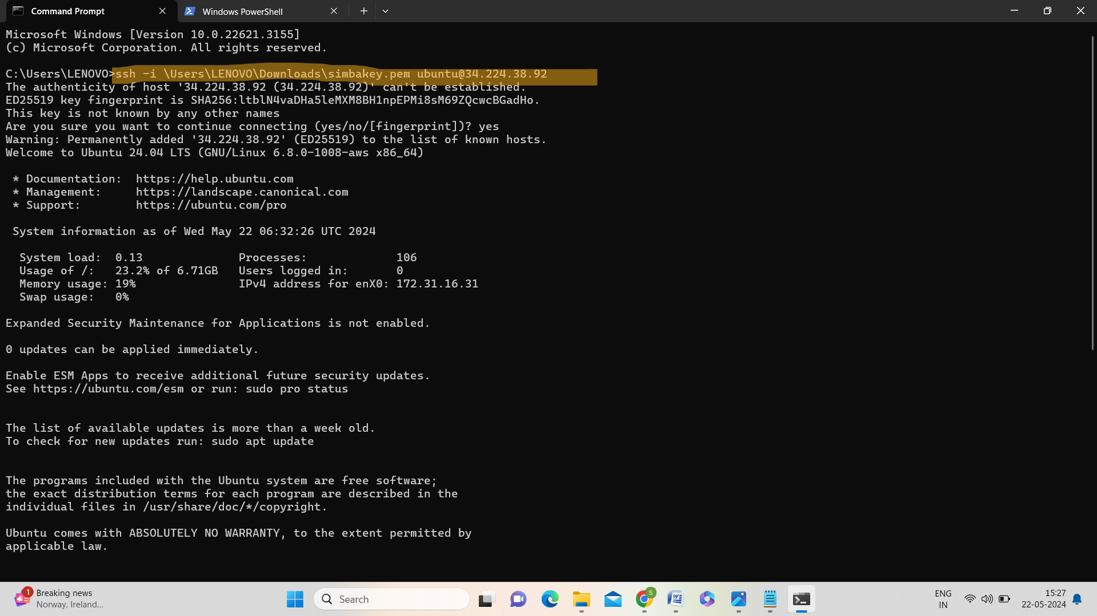

(OR)

